Arduino Mega2560 ESP 8266 Huzza BME280 DS3231 ThingSpeak Internet of Things Project

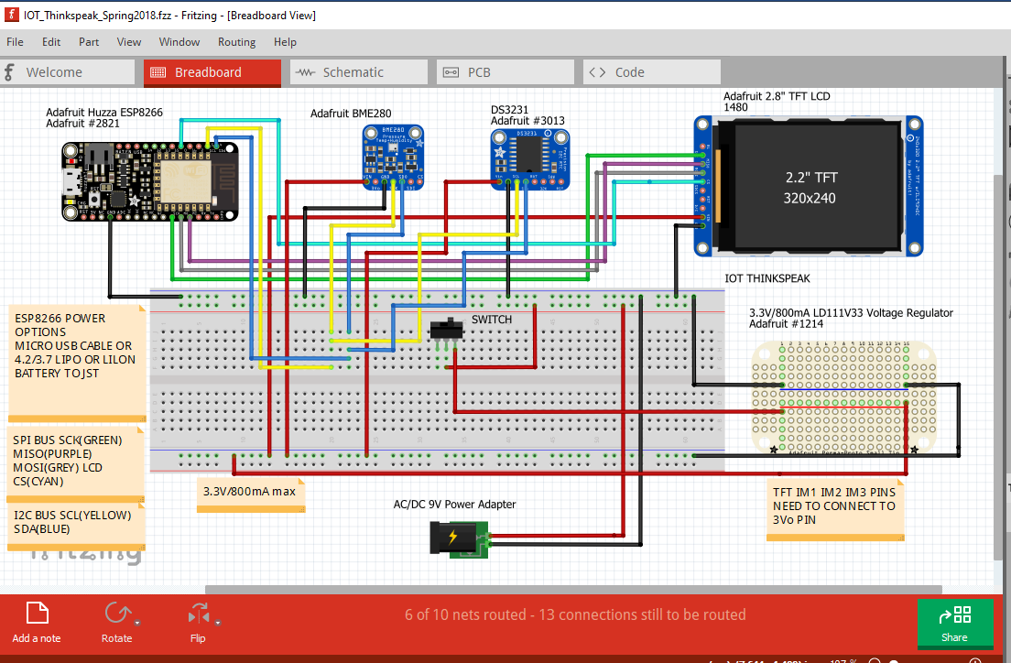

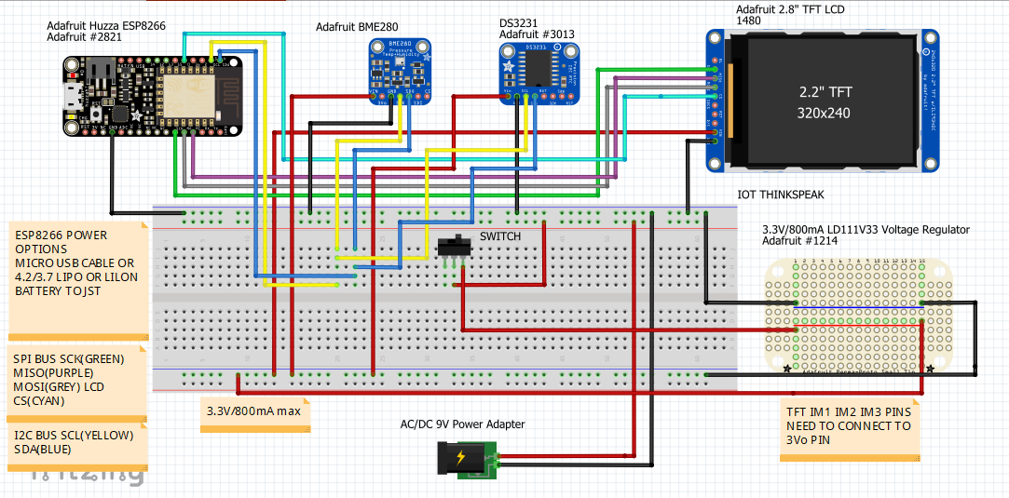

Note: If external power is supplied to the ESP 8266 before downloading source code to ESP through the USB the external power source needs to be disconnected.

Arduino Code: Mega_Huzza_BME280_DS3231_ThingSpeak

